Da assignment 2-

Part -1:

1. Load the input data from the file “Assignment_DA_2_a_data.xlsx” [1 point]. Note that not all fields are filled, for example Supplier C does not stock Material A. Make sure to use the data from the file in your code, please do not hardcode any values that can be read from the file.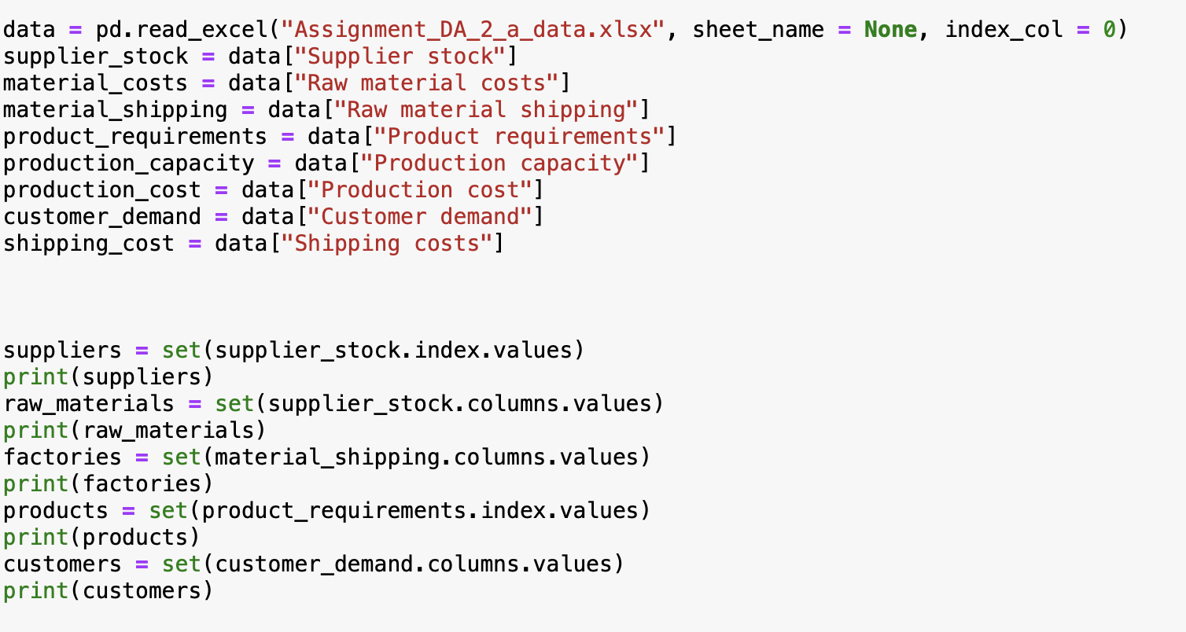

We begin by loading the data from the assignment_da_2 excel file, we load all the 6 sheets in the data to a data frame

We perform a sanity check by printing each of the unique values or the information and store in a set data structure. This shows how many factories suppliers, materials , product and customers are available.

1. Identify and create the decision variables for the orders from the suppliers [1 point], for the production volume [1 point], and for the delivery to the customers [1 point] using the OR Tools wrapper of the GLOP_LINEAR_PROGRAMMING solver.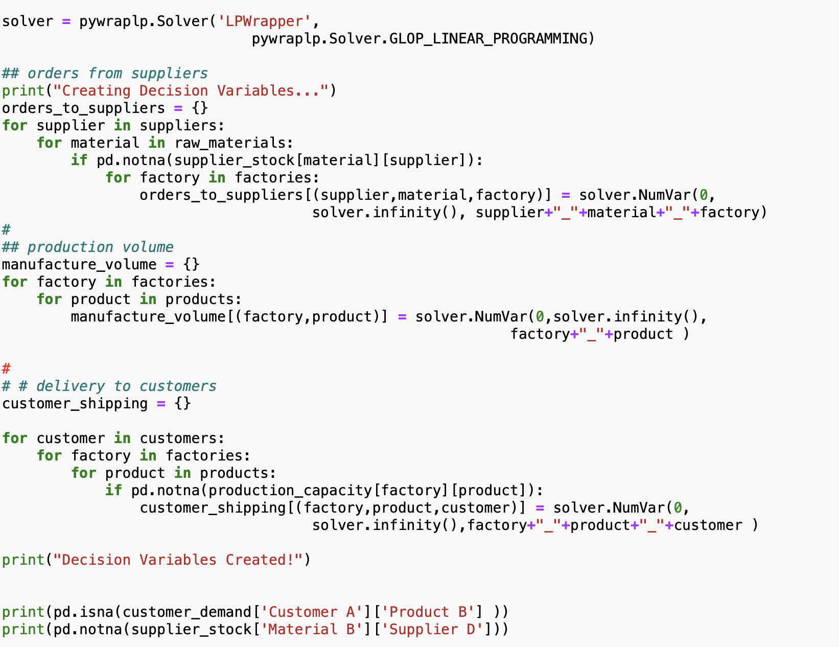
2. Define and implement the constraints that ensure factories produce more than they ship to the customers [2 points].
3. Define and implement the constraints that ensure that customer demand is met [2 points].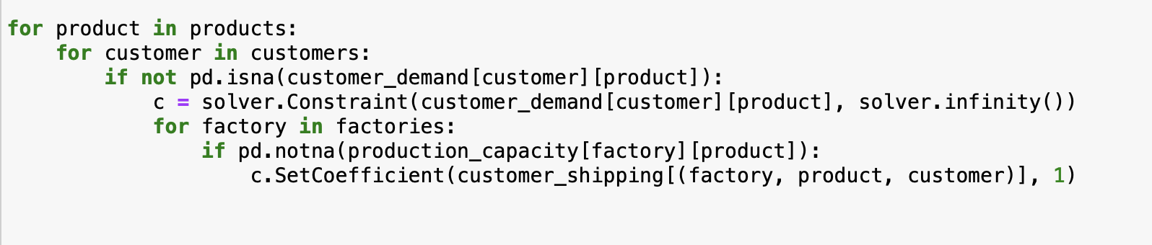
4. Define and implement the constraints that ensure that suppliers have all ordered items in stock [2 points].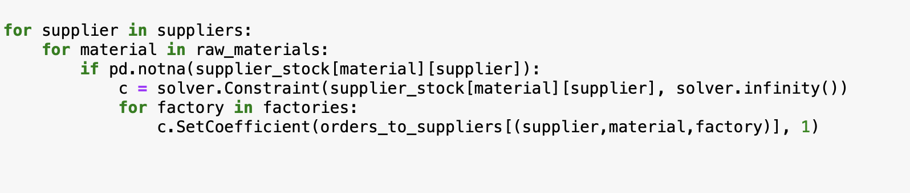
5. Define and implement the constraints that ensure that factories order enough material to be able to manufacture all items [2 points].
6. Define and implement the constraints that ensure that the manufacturing capacities are not exceeded [2 points].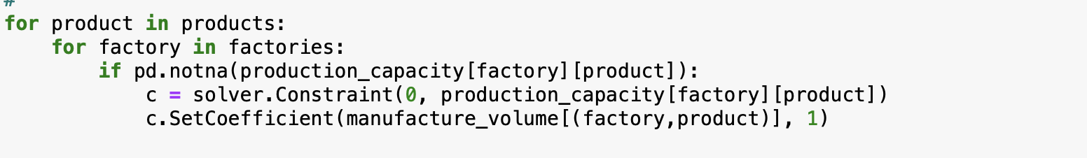

1. Define and implement the objective function. Make sure to consider the supplier bills comprising shipping and material costs [2 points], the production cost of each factory [2 points], and the cost of delivery to each customer [2 points].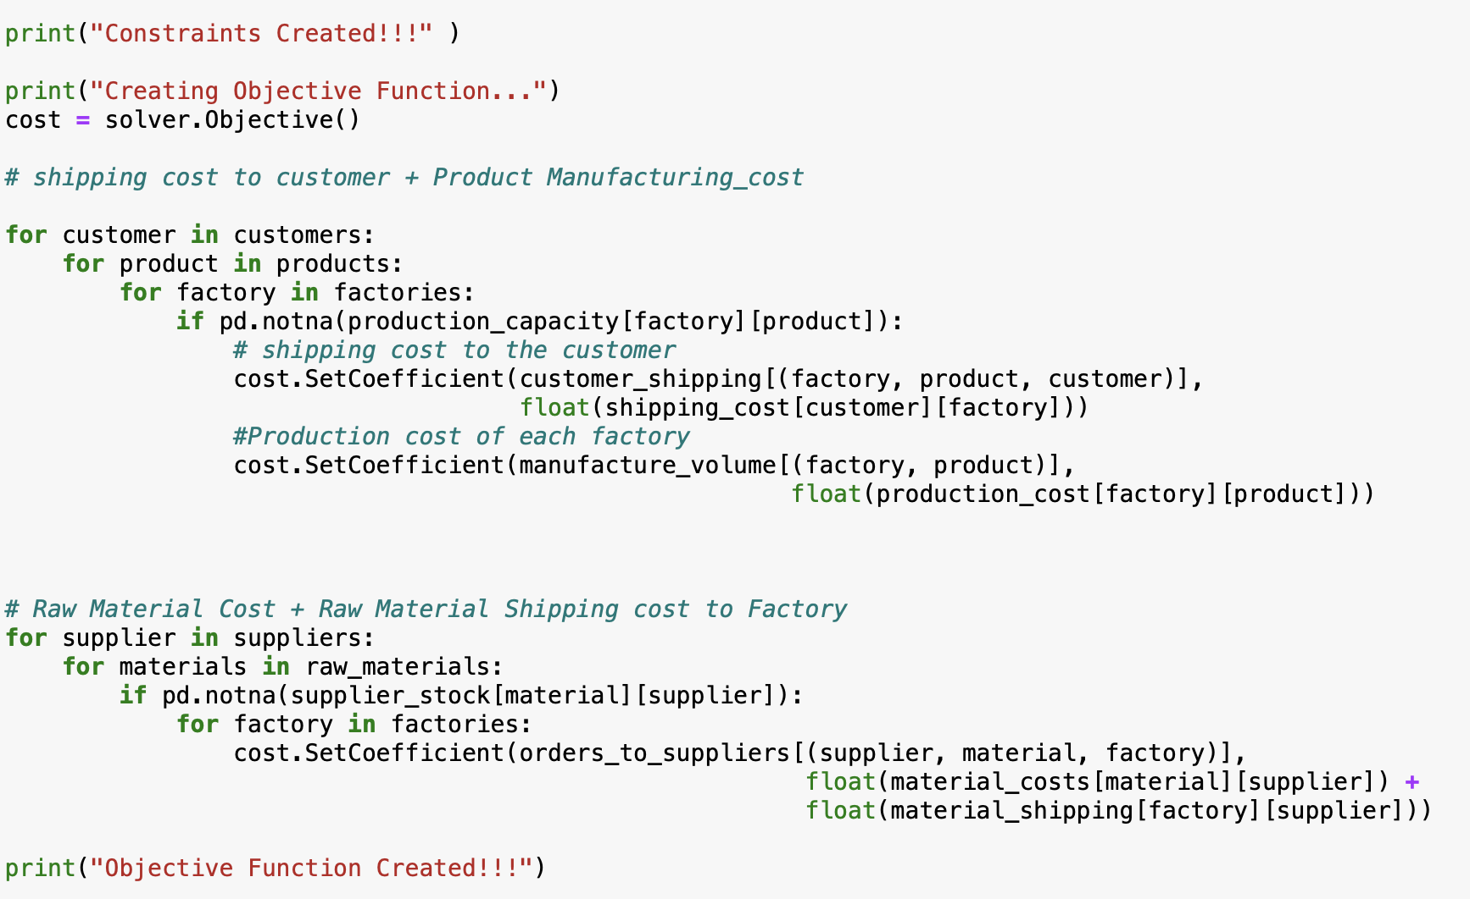

1. Solve the linear program and determine the optimal overall cost [1 point].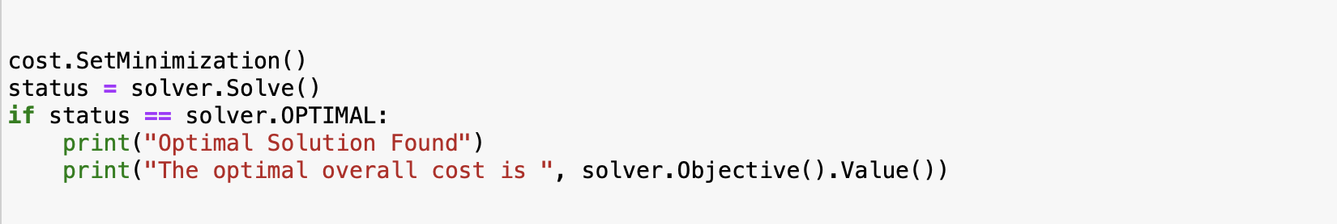
2. Determine for each factory how much material has to be ordered from each individual supplier [1 point].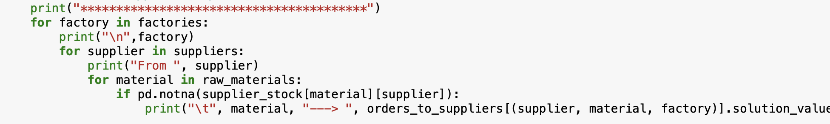

1. Determine for each factory what the supplier bill comprising material cost and delivery will be for each supplier [1 point].   
   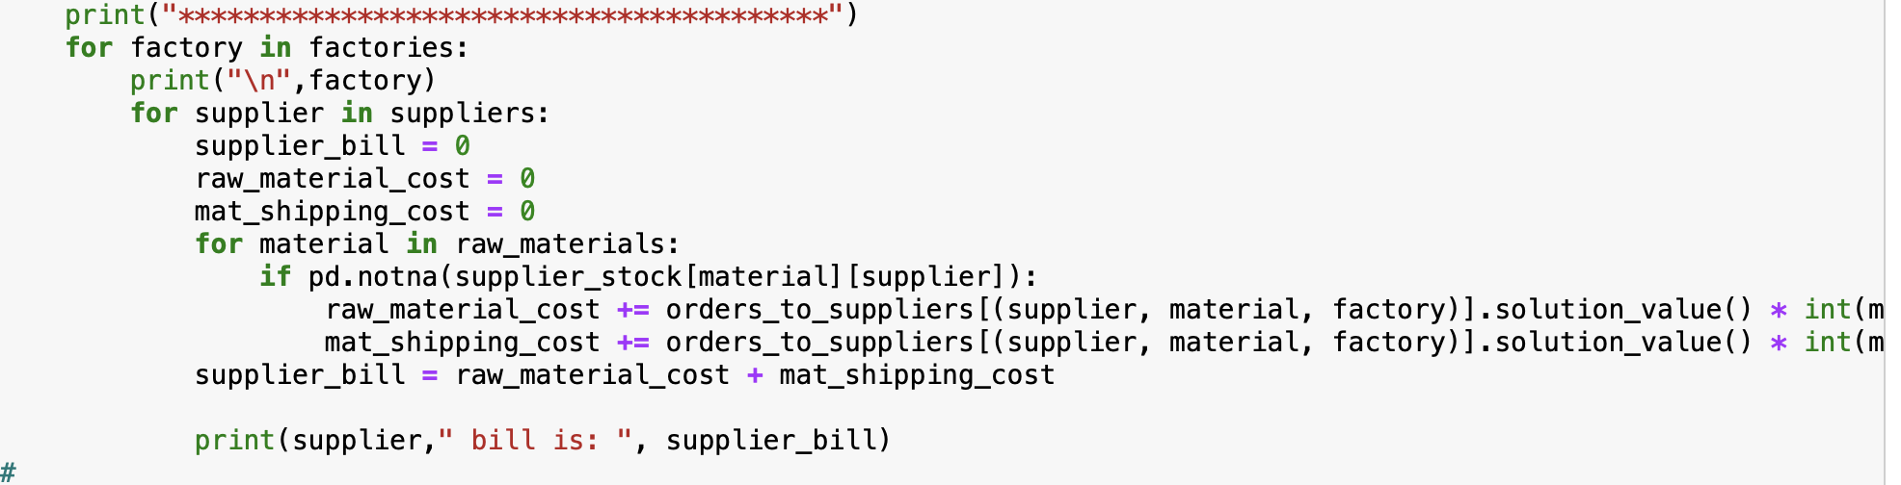
2. Determine for each factory how many units of each product are being manufactured [1 point]. Also determine the total manufacturing cost for each individual factory [1 point].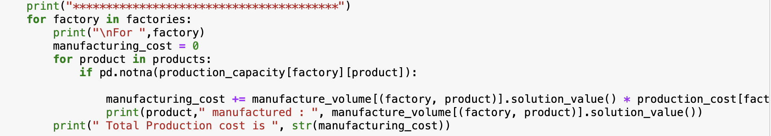

1. Determine for each customer how many units of each product are being shipped from each factory [1 point]. Also determine the total shipping cost per customer [1 point]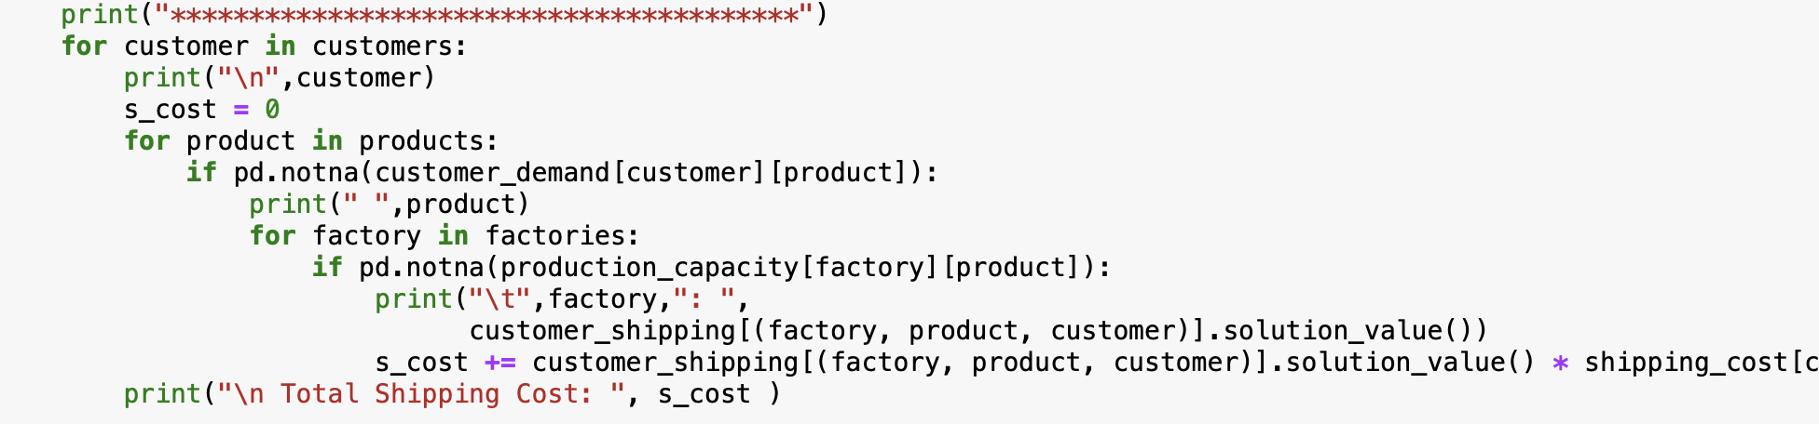
2. Determine for each customer the fraction of each material each factory has to order for manufacturing products delivered to that particular customer [1 point]. Based on this calculate the overall unit cost of each product per customer including the raw materials used for the manufacturing of the customer’s specific product, the cost of manufacturing for the specific customer and all relevant shipping costs [2 points].   
   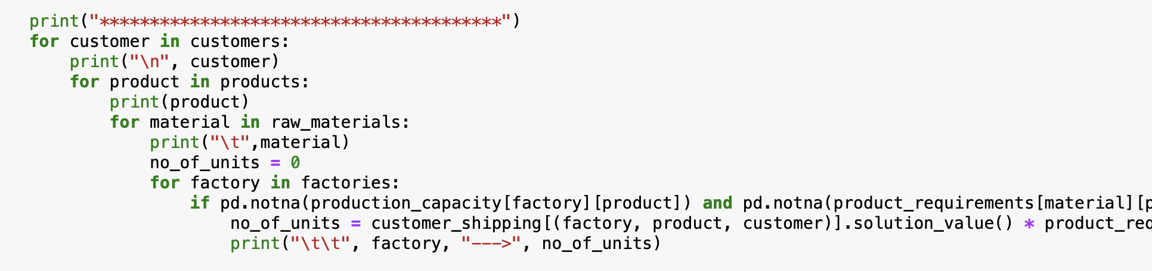

Part 2:

1. Load the input data from the file “Assignment_DA_2_b_data.xlsx” [1 point]. Make sure to use the data from the file in your code, please do not hardcode any values that can be read from the file.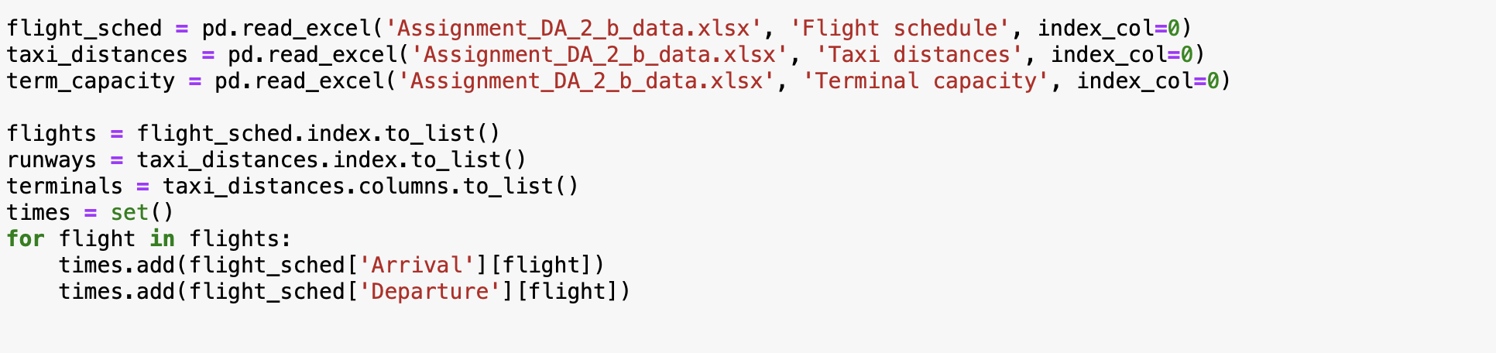
2. Identify and create the decision variables for the arrival runway allocation [1 point], for the departure runway allocation [1 point], and for the terminal allocation [1 point] using the OR Tools wrapper of the CBC_MIXED_INTEGER_PROGRAMMING solver.
3. Define and create auxiliary variables for the taxi movements between runways and terminals for each flight [1 point].   
   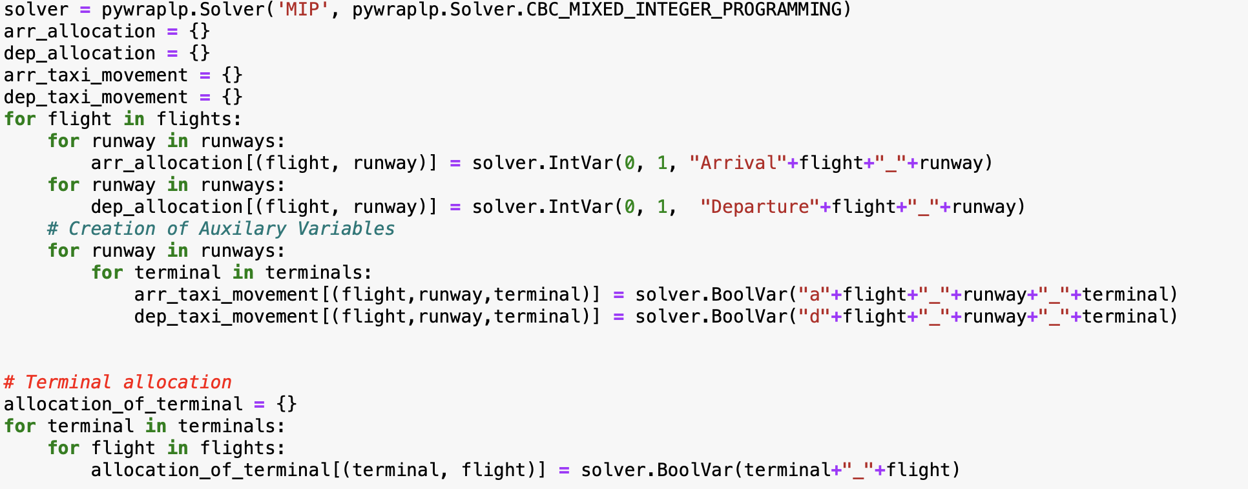
4. Define and implement the constraints that ensure that every flight has exactly two taxi movements [1 point].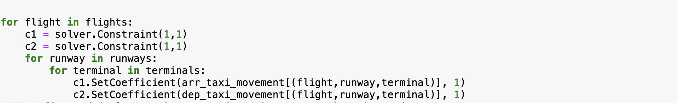
5. Define and implement the constraints that ensure that the taxi movements of a flight are to and from the allocated terminal [1 point].   
   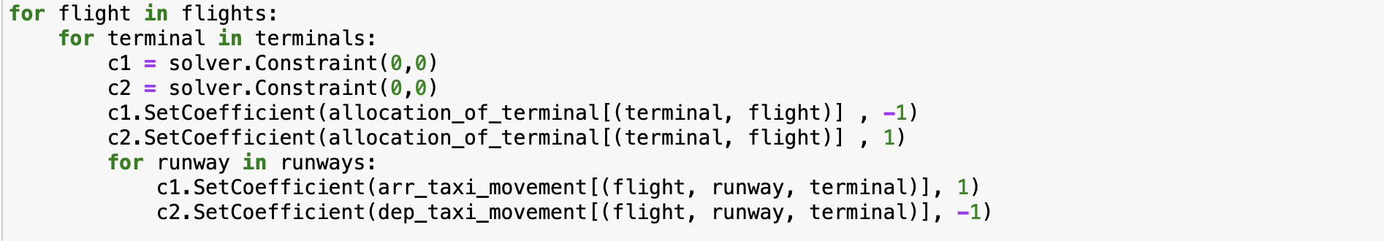
6. Define and implement the constraints that ensure that the taxi movements of a flight include the allocated arrival and departure runways [1 point].   
   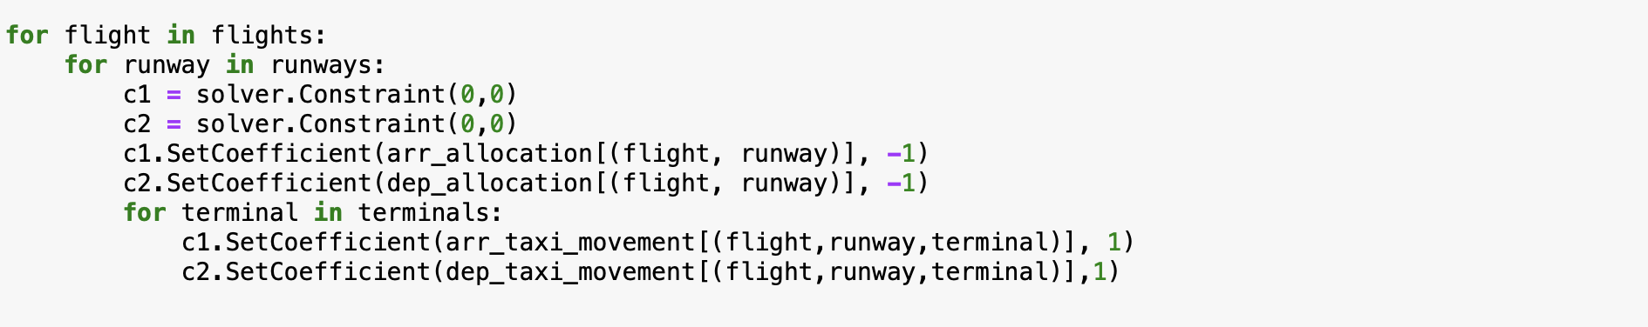
7. Define and implement the constraints that ensure that each flight has exactly one allocated arrival runway [1 point] and exactly one allocated departure runway [1 point].   
   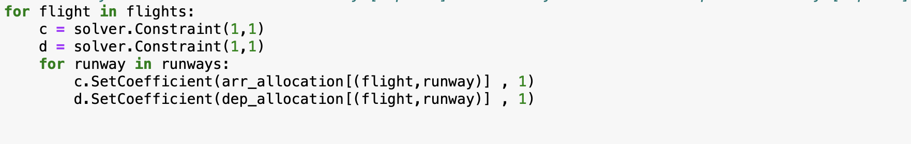
8. Define and implement the constraints the ensure that each flight is allocated to exactly one terminal [1 point].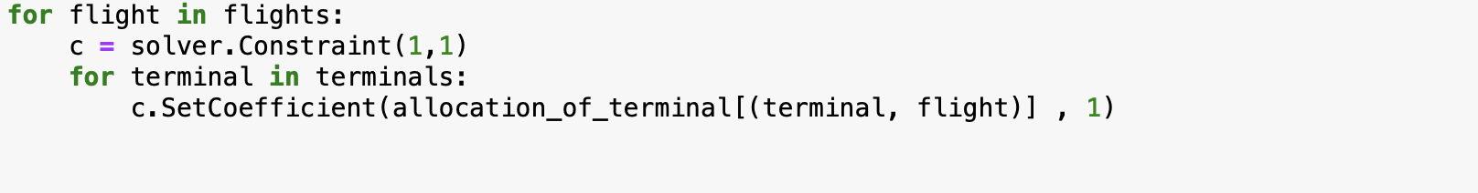
9. Define and implement the constraints that ensure that no runway is used by more than one flight during each timeslot [1 point].
10. Define and implement the constraints that ensure that the terminal capacities are not exceeded [1 point].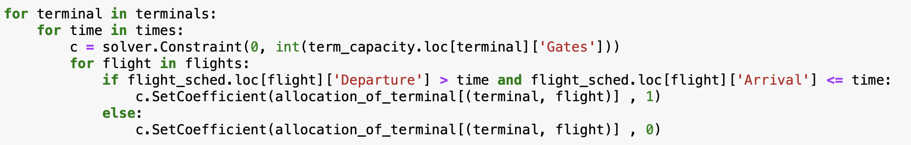
11. Define and implement the objective function [1 point]. Solve the linear program and determine the optimal total taxi distances for all flights [1 point].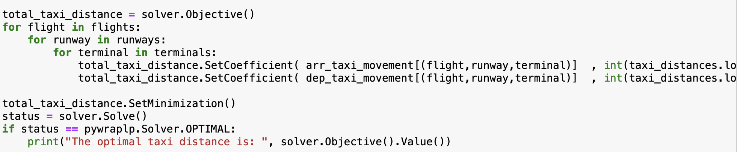
12. Determine the arrival runway allocation [1 point], the departure runway allocation [1 point], and the terminal allocation [1 point] for each flight. Also determine the taxi distance for each flight [1 point].   
    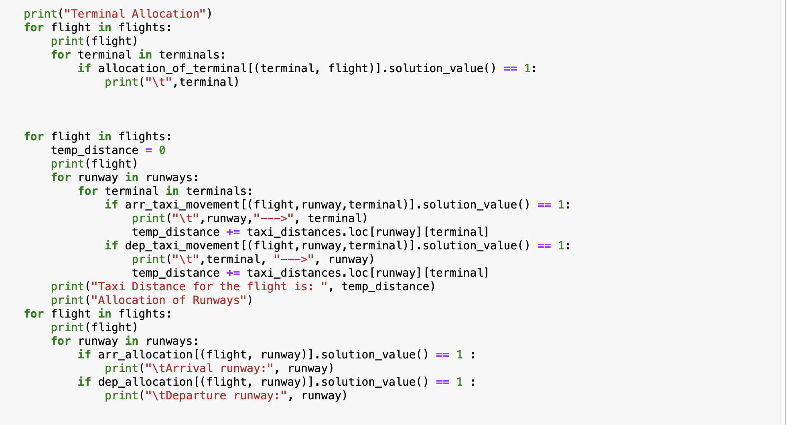
13. Determine for each time of the day how many gates are occupied at each terminal [1 point].

(kindly see the console output of the code)